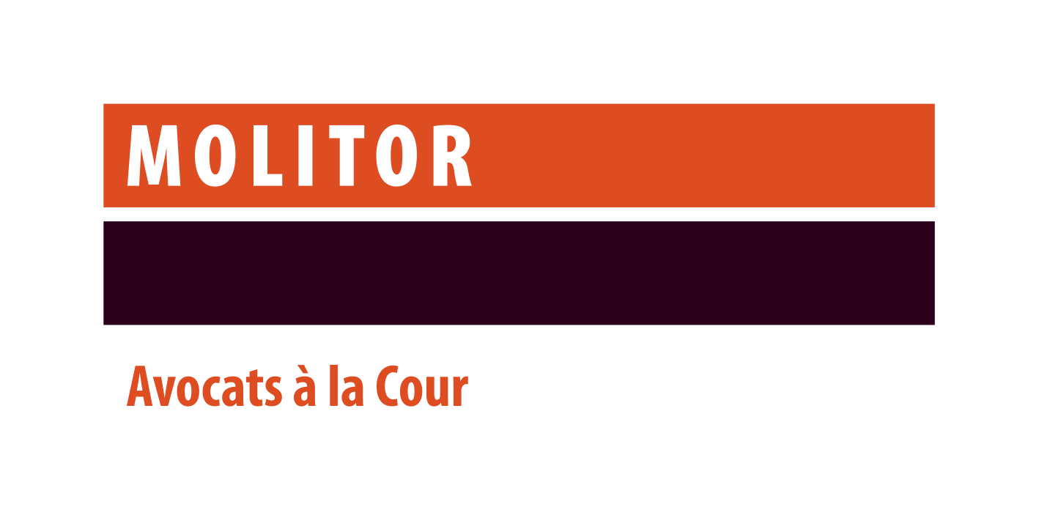

Lawyer for our Litigation & Dispute Resolution practice
Contact: Sophie Icher
Head of HR and Organisation
sophie.icher@molitorlegal.lu

Your mission
Assisting our clients in a variety of litigation matters relating to Banking & Finance, Investment Management and in Restructuring & Insolvency matters.

Your profile
- University degree in law completed by a post-graduate degree;
- Member of the Luxembourg Bar;
- At least 5 years’ experience in a recognized law firm and a solid technical background in litigation.
- Personal communications skills;
- Excellent written communication and drafting skills;
- Fluent (written and spoken) in both French and English. Proficiency in Luxembourgish and German would be highly appreciated;
- Team player and client oriented

What we offer

- An exciting business environment at an independent and full-service law firm.
- Working within an international team of highly regarded lawyers (and one of the top dispute resolution firms – to be adapted depending on the PG) in Luxembourg.
- Internal and external training to foster your continuous professional development.
- A people-oriented and multicultural environment which embraces diversity and inclusiveness.
Our values:

We have a strong focus on how we recruit, train and reward our staff and always ensure that they are fully aligned with our work culture built around our four core values:
- Service Excellence - We seek to exceed our clients’ expectations, through impeccable quality advice and deliverables
- Integrity & Trust - We ‘walk the talk’ – Being widely trusted by all our counterparts is essential to us
- Teamwork - We place team goals above individual goals
- Approachability - Building rapport with all our counterparts is a key priority for us

